## **CSCI 6370 IR and Web Search**

## Homework Assignment Four

Total points: 100. Due: Monday, June 29.

This assignment is designed for you to get familiar with the concepts of hubs and authorities using the HITS algorithm, and the PageRank algorithm.

Given the following four web pages and their reference links, compute the first two rounds the following algorithms. Show the results and the steps of computation. If you use programs or spreadsheets, show the formula and results on a separate piece of paper besides submitting the programs or the spreadsheets to me.

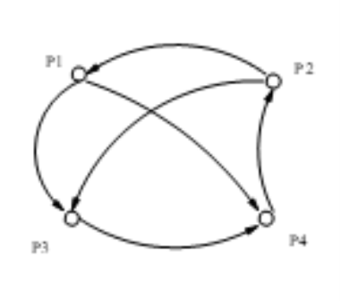

Figure 1: Configuration of the four web pages

1. [50 points] The HITS algorithm for hubs and authorities.

Initialize for all $p∈S:a_{p}=h_{p}=1$

For $i = 1$ to numOfSteps do //Here we set numOfSteps = 5

For all $p∈S:a_{p}=Σ_{q:q→p}{ h}_{q}$

For all $p∈S:h_{p}=Σ_{q:p→q}{ a}_{q}$

For all $p∈S:a_{p}=a_{p}/c, \text{where} c=\sqrt{Σ_{p∈S}{ a}_{p}^{2}}$

For all $p∈S:h_{p}=h_{p}/m, \text{where} m=\sqrt{{ Σ}_{p∈S}{ h}_{p}^{2}}$

1. [50 points] The PageRank algorithm for page ranks.

Let $S$ be the total set of pages.

Let $∀p∈S:E\left(p\right)=α/\left|S\right|$//Here we set $α=0.15$

Initialize $∀p∈S:R\left(p\right)=1/\left|S\right|$

Until ranks do not change much //Here we do 5 iterations

for each $p ∈ S$:

$R^{'}\left(p\right)=Σ_{q:q→p}\frac{R\left(q\right)}{N_{q}}+E\left(p\right)$

$c=1/Σ_{p∈S}R^{'}\left(p\right)$

for each $p ∈ S$:

$R\left(p\right)=c⋅R^{'}\left(p\right)$